Meet the Year 7 Staff and Form names for 2024-2025
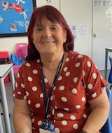
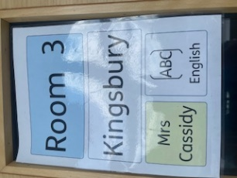
KINGSBURY Room 3
Mrs Cassidy
Mrs Cassidy teaches English and is Head of the Department. She comes from Ireland and loves all things green! Get Ready for St Patrick’s Day!
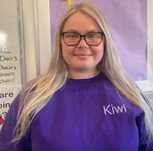
Miss McCarthy
Miss Mac has worked with Year 7 last year and is looking forward to sharing in lots of fun activities in the Form group. Miss Mac works with the English Team.

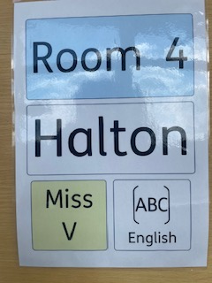
HALTON Room 4
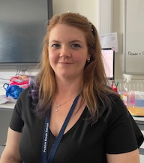
Miss Van der Westhuizen (Miss V)
Miss V is an English Teacher is an English Teacher. She comes from South Africa and no doubt will teach you some ‘Afrikaan.’
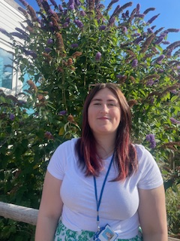
Miss Anson
Miss Anson has worked with Year 7 last year and is also part of the English Team. She particularly enjoyed visiting North Yorkshire with 40 KS3s in April and is looking forward to lots of fun activities with her Form group.

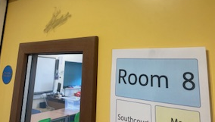
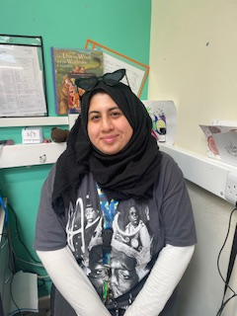
STONE Room 8
Miss Oguirhil (Miss O)
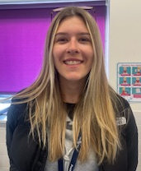
Miss O will be teaching a range of subjects: English, Maths, Science, Art in Room 8. One special thing to know about Miss O is she always is very colour co-ordinated, especially with glasses and shoes of every colour!

Miss Williams Miss Williams is looking forward to getting to know all the new Year 7s. She has loved working in Bedgrove and joining in the singing and dancing with Electric Umbrella. At home she is busy looking after her three dogs and would love to know about the Y7 pets!
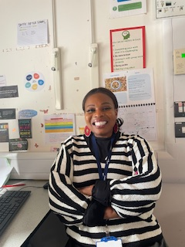
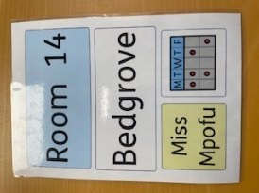
BEDGROVE Room 14
Miss Mpofu (Miss M)
Miss M is the Head of Bedgrove, Brill and Berryfields Form groups. Ms M comes from Zimbabwe and loves dancing and singing. She has loved sharing how to cook some of her favourite food from Zimbabwe. She is looking forward to helping everyone settle into the Form. See you all in September!
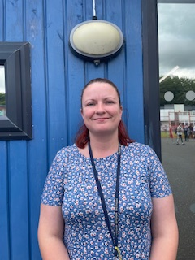
Miss Wallace
Miss Wallace loves working in the Bedgrove, Berryfields and Brill classes. Miss Wallace is good at practising her Makaton signing and is looking forward to meeting all of the new Year 7s. Miss Wallace is very good at cooking and so she is sure you will have a good time learning new skills in the cookery room!

