Christmas Cards Order Form 2023
30p each or a pack of 4 for £1:20

Price: A pack of 4 different designs for £1:20, or 30p per card.
I would like…………. Pack(s) of Christmas cards (random designs), Cost £…………….
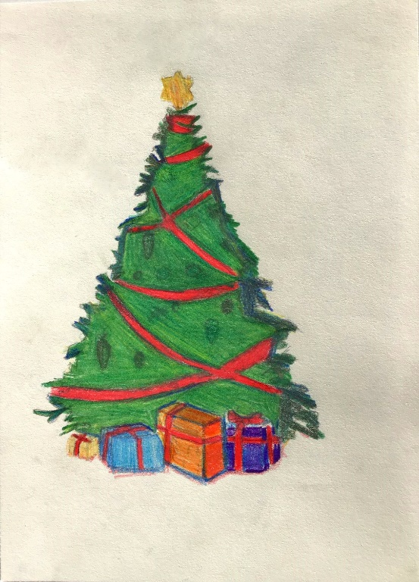
I would like…………card(s) of design A, Cost £…………….
I would like…………card(s) of design B, Cost £…………….
E
I would like…………card(s) of design C, Cost £…………….
I would like…………card(s) of design D, Cost £…………….
I would like…………card(s) of design E, Cost £…………….
Total cost £ ……… Paid: Yes/ No
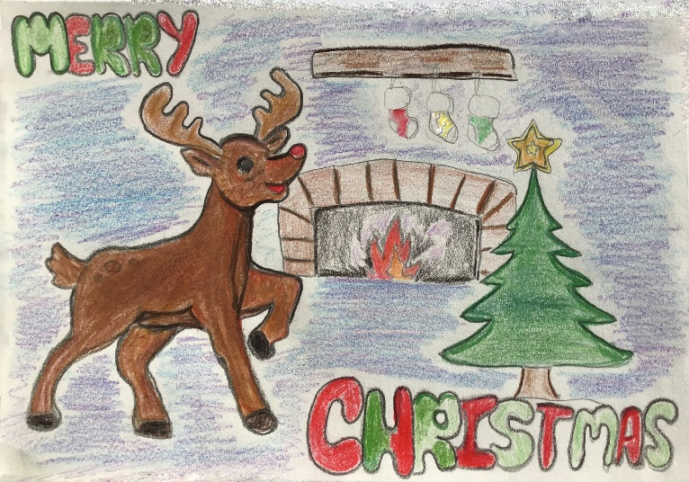
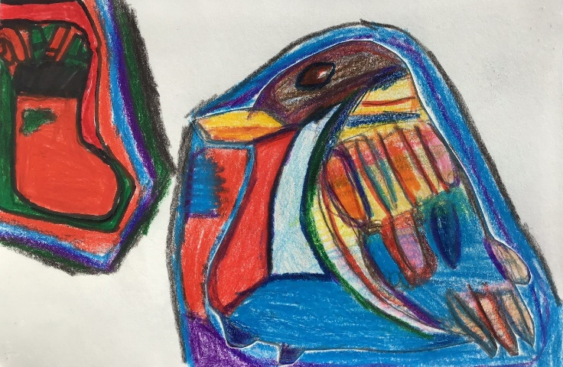
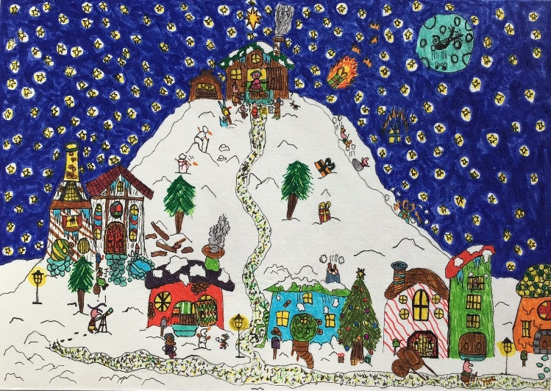
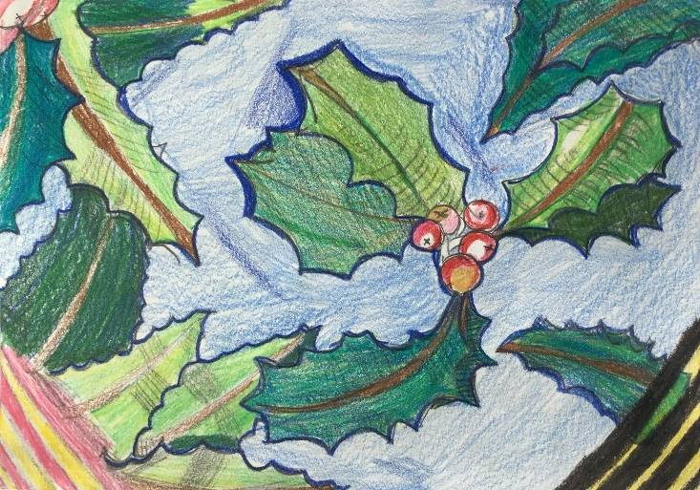
A
B
C

D

