Christmas items available to purchase from the school.
Please tick if you would like to order anything, and return the slip at the bottom with the money to your child’s form tutor by the 13th December. Thank you for your support.
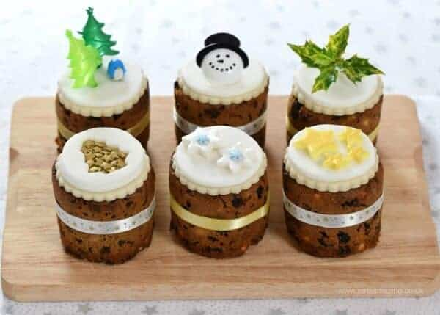
Mini Christmas Cakes

£3 each, or 2 for £5

………………………………………………………………………………………………………………………………………………………………………………..
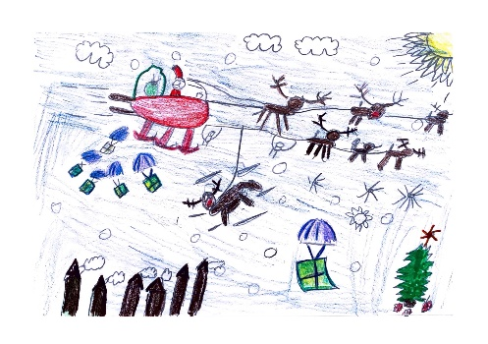
Christmas postcards designed by KS3 pupils
(these are postcards, but are great to use as Christmas
Cards and have an envelope provided)
Design A

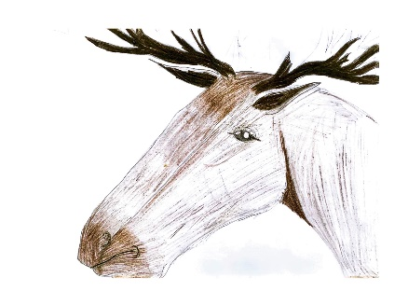
25p each

Design B

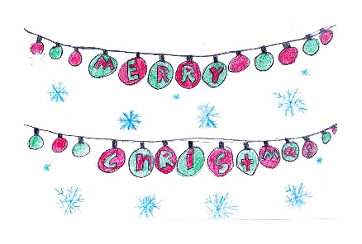

Design C

Design D

………………………………………………………………………………………………………………………………………………………………………………..
I/we ……………………………………………. (insert name) would like to order the following:
- Mini Christmas Cakes ……………..(insert number). Total amount £…....

- Christmas Postcards: Design A …..(insert number), Design B……(insert number), Design C…..(insert number),
Design D …….(insert number). Total amount £…………

