Very Best Scones
Ingredients:  250g SR Flour  75g Margarine  50g sugar  1 egg  100ml milk approx.  ………………………. | 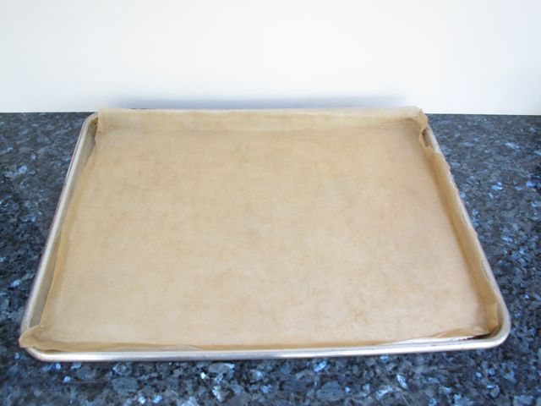  1. Line a baking tray with baking paper. | 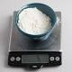  2. Weigh the flour and tip it into a mixing bowl. | 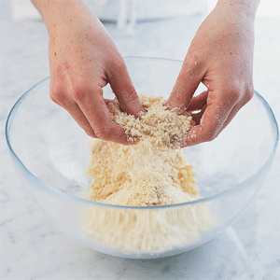  3. Add 75g margarine into the flour, and rub it in with your fingertips. | Equipment:  Cheese grater  Baking tray  Scales  Mixing bowl  Tablespoon  Pie Plate  Measuring jug  Cutter
 | 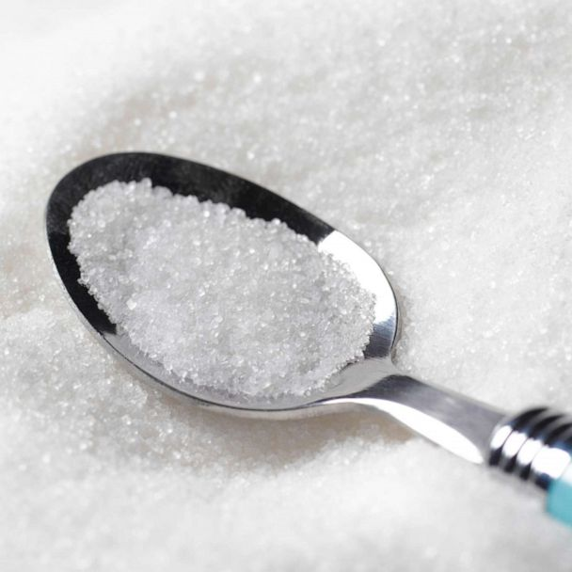  4. Stir in the sugar. | 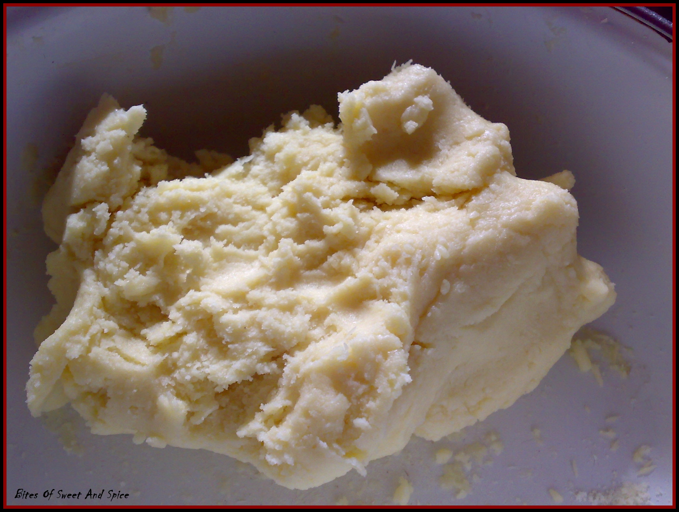  5. Beat the egg together with the milk, and add to the bowl. Bring the mixture to a soft dough. | 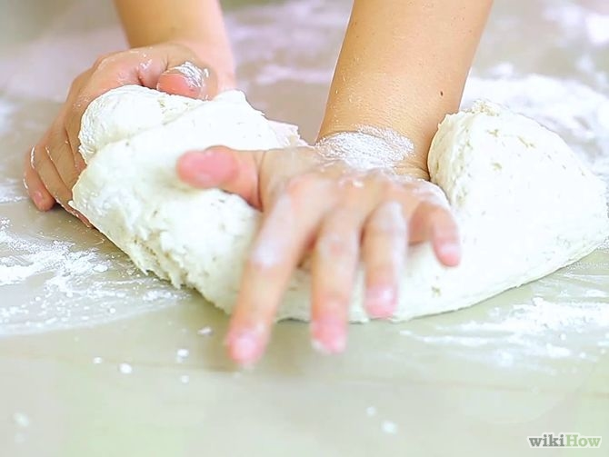  6. Turn onto a floured surface and flatten it out.
 | 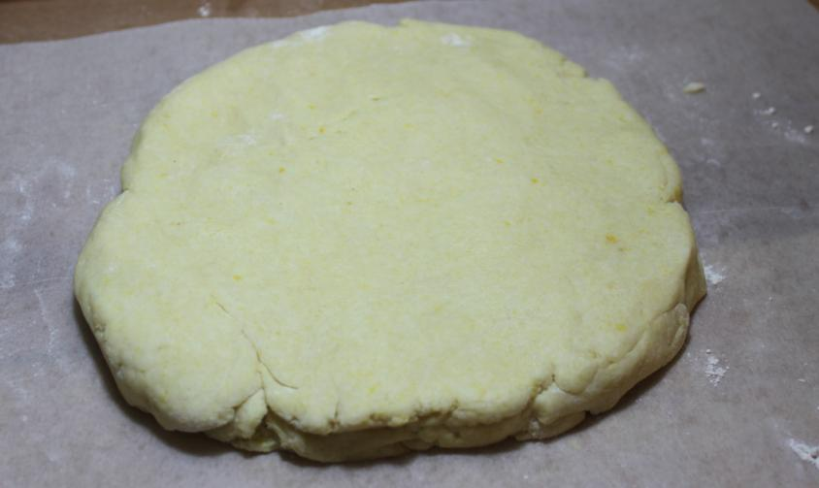  7. Pat out the dough until it is about the thickness of a £1 coin. | 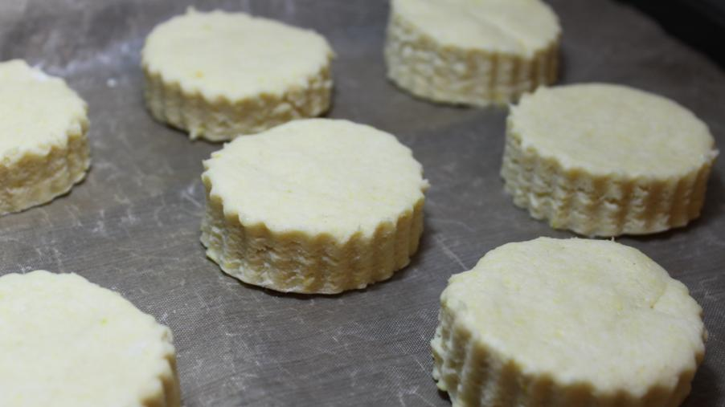  8. Cut out 8 scones using a 5cm or 2” cutter. | 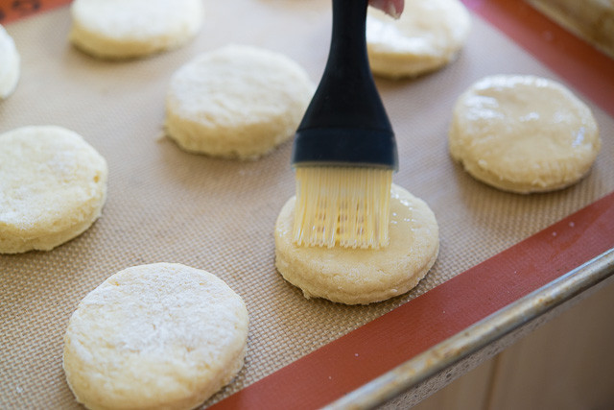  9. Brush tops of scones with milk and bake at 200C for 12 - 15 minutes

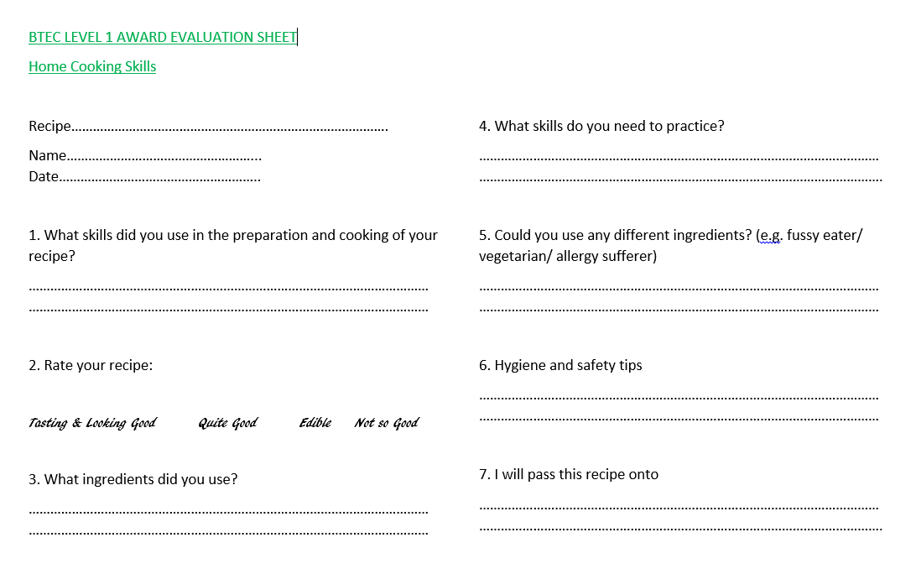

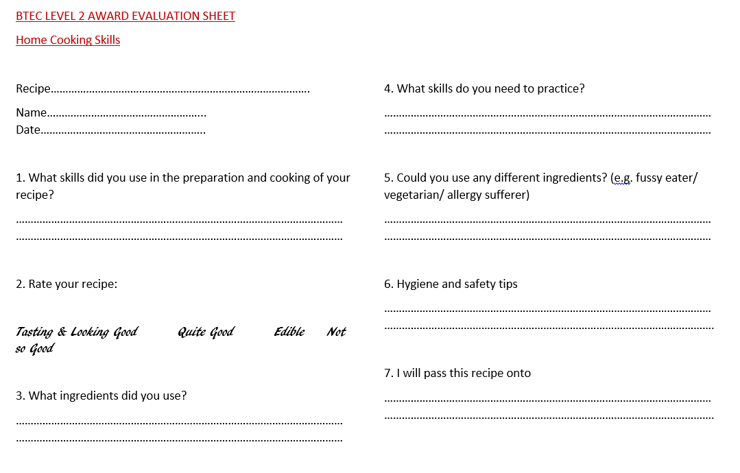
BTEC LEVEL 2 CONTINUED


