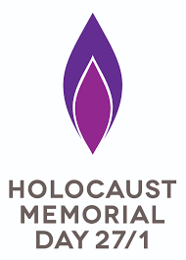
Holocaust Memorial Day 2021
Be the light through the darkness.
21 January 2021

As we come towards the 76th anniversary of the liberation of the concentration camp of Auschwitz Birkenau, I feel it is important to remember the victims of the Holocaust during this very strange and uncertain time.
Due to the pandemic at the moment the remaining holocaust survivors continue to give their inspiring testimonies through the use of technology.
One such event happened on 20th January this year, an online event hosted by BBC news politic editor Laura Kuenssenberg with guests former Member of Parliament David Milliband. On 26th January, Natasha Kapinsky also spoke with survivor Eve Kugler, which I found moving.
I feel that it is deeply important that the legacy of this dreadful part of our history must continue to be passed on regardless of the current situation.
I also have hope that despite this pandemic, the legacy of the Holocaust will never be forgotten. This is thanks to the use of technology, being able to communicate with survivors and with members of both the Holocaust Educational Trust and the Holocaust Memorial Trust, in order to educate the next generation.

Benjamin Richardson.
