Week Beginning: Monday 11th January 2020
KS3 Science
LO: To learn about different Habitats and Micro-Habitats.

I can name different Habitats

In the yellow boxes, name each habitat. You may use the word bank to help you.
Word Bank
Marine Desert Mountains Grasslands
Polar Regions Rainforest Wetlands Urban

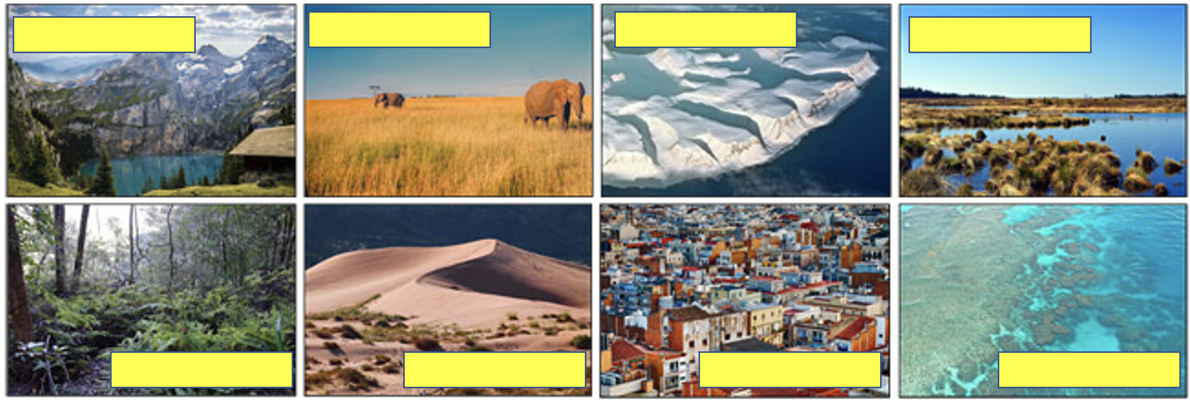

Can you think of animals or plants that might live in one of these habitats and give an example?
_______________________________________________________________________________________

I can describe micro-habitats and the animals that might live there
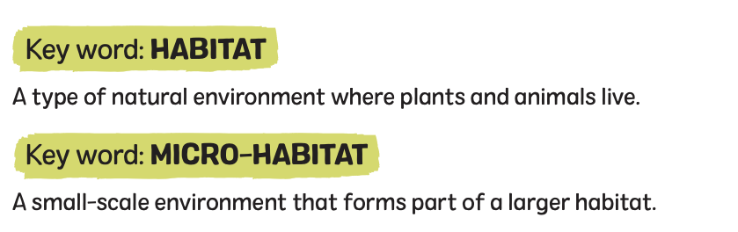

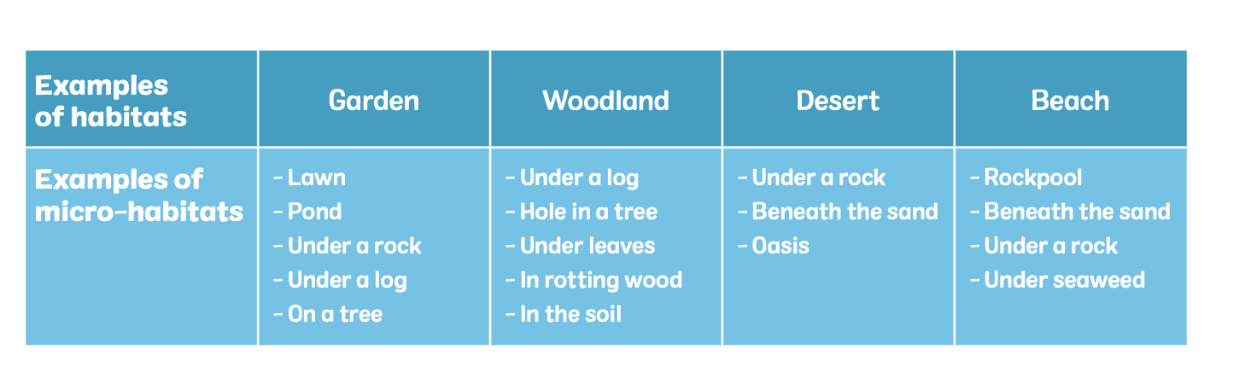

What micro-habitats do you have in you have home or garden?

Wetlands are one of the most important habitats on earth – storing huge amounts of CO2, providing a natural way of stopping flooding and serving as a home for huge numbers of different creatures.

Look at the Visual of the UK Wetland Habitat. Which micro-habitats can you see?
Could you number them to match the visual? The first one has been completed to give you an example:
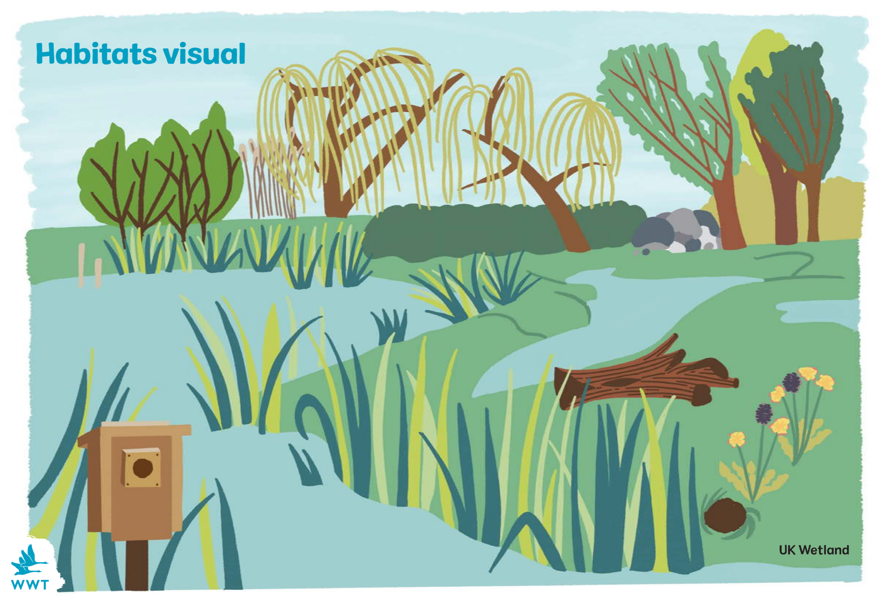

1
Micro-Habitats in a UK Wetland Habitat:

1. Bird nest box
Hole in the ground
Log
Pond
Rock pile
Bushes
Trees
Under the ground

Could you complete the table to give examples of animals in each micro-habitat?

 | Bird nest box | Hole in the ground | Log | Pond | Rock pile | Bushes | Trees | Under the ground
Examples
of
animals that may live there
Some examples: Fox, Rabbit, Grasshopper, Earthworm, Sparrow, Woodlouse, Squirrel, Badger, Beetle, Centipede.
You may use some other examples included on the following pages.

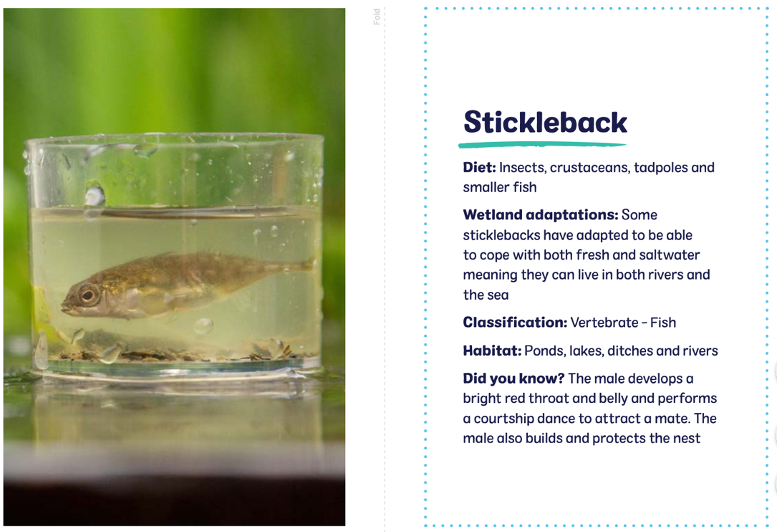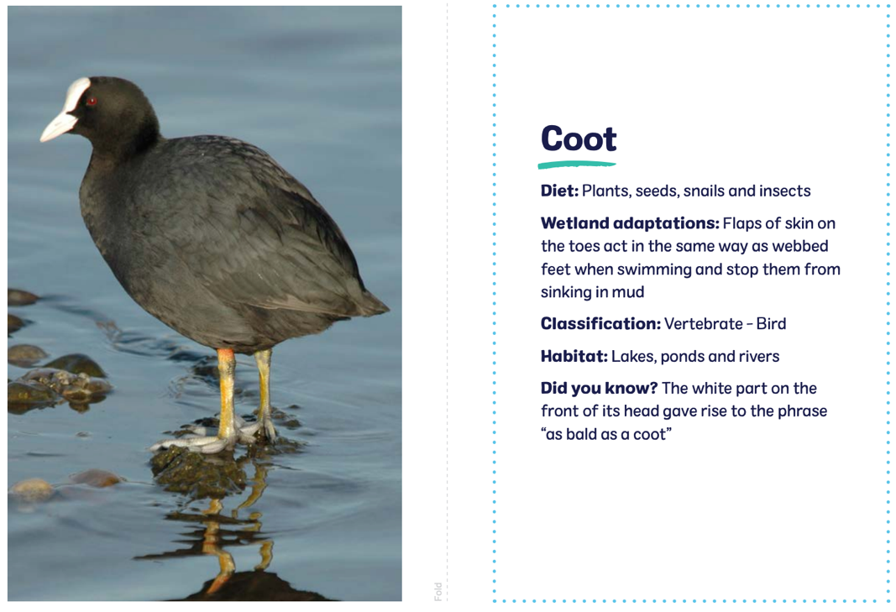
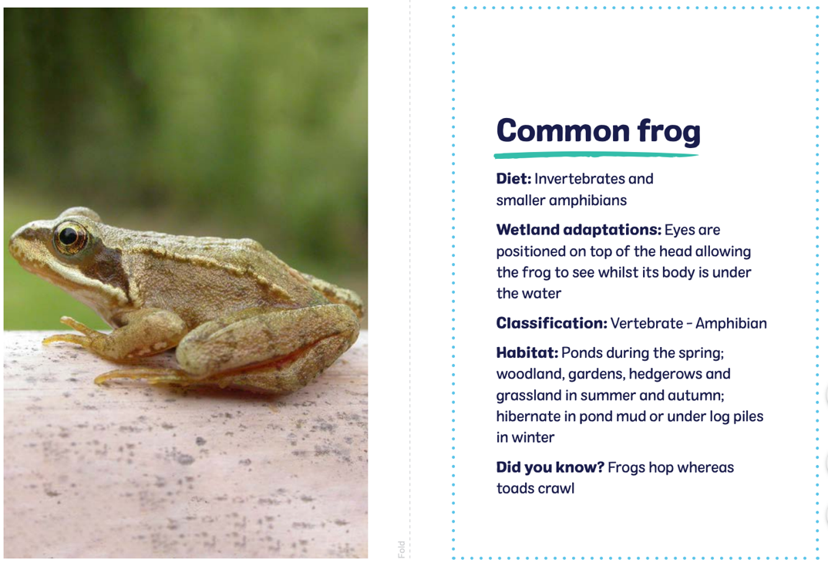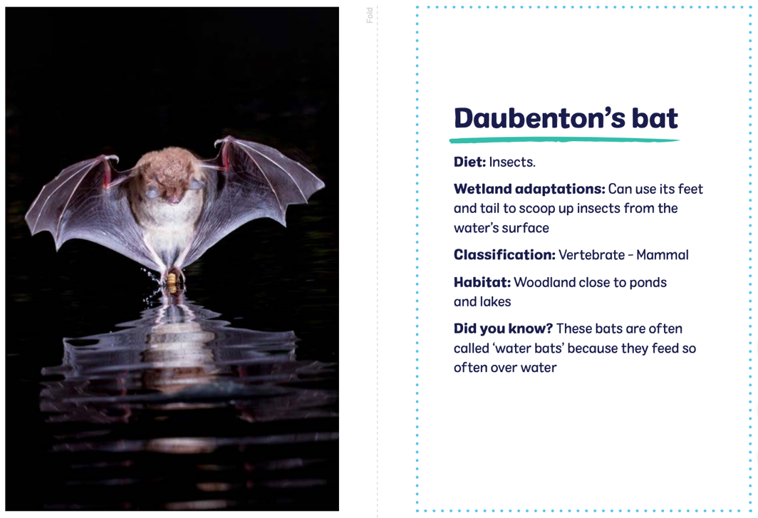

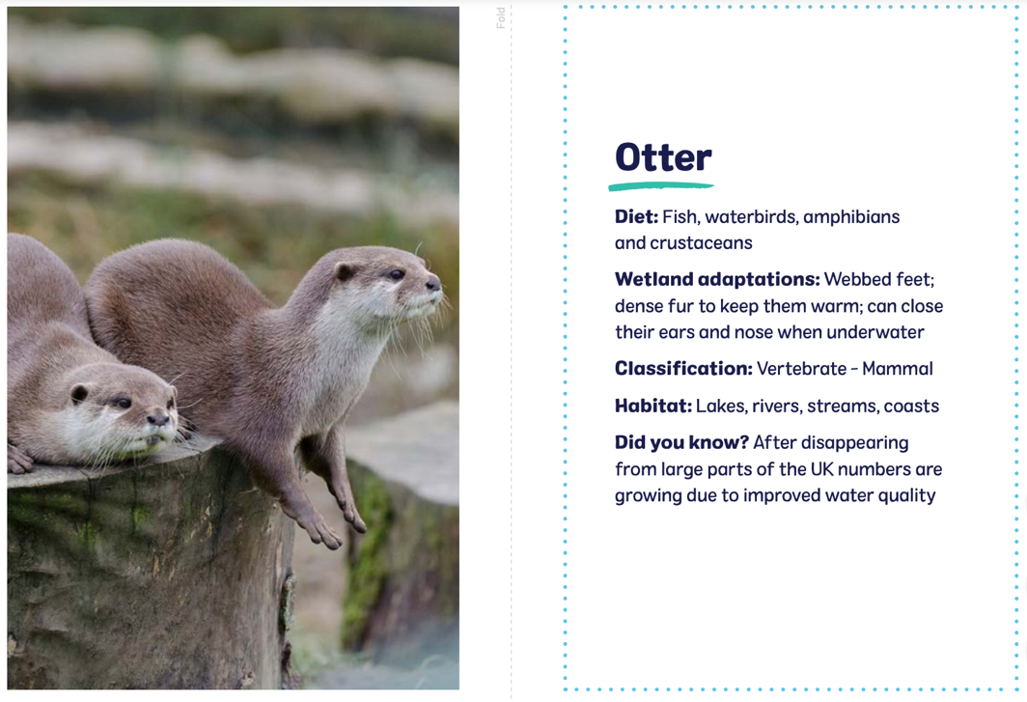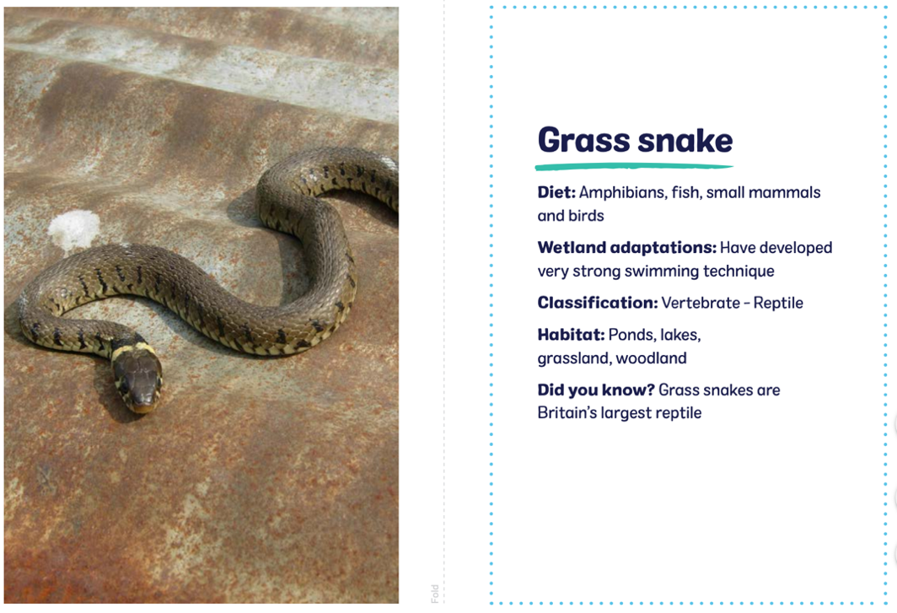
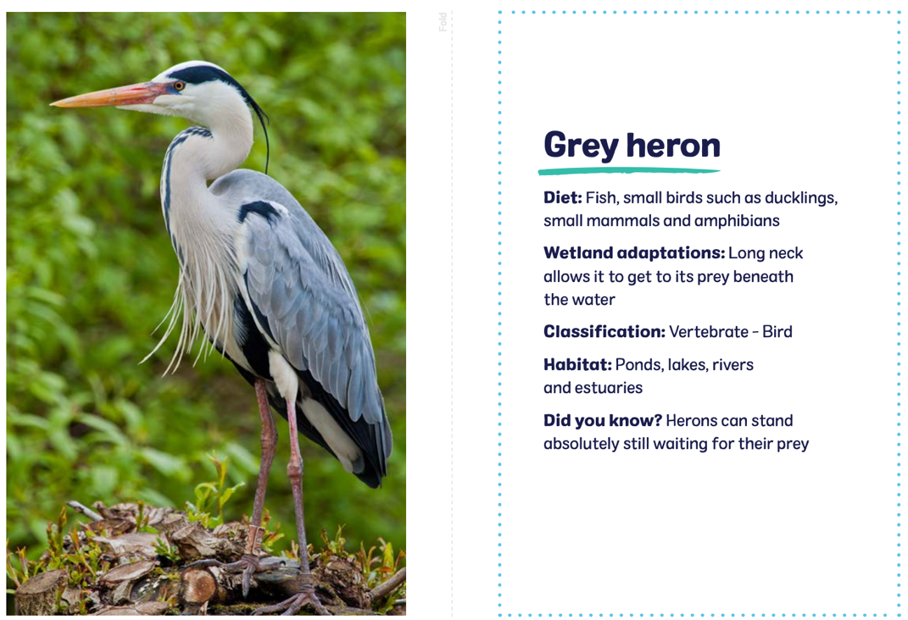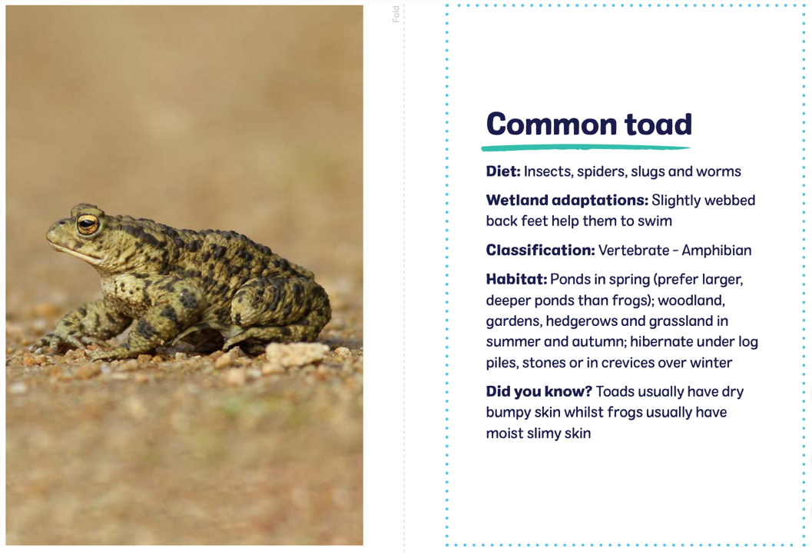

I can design a micro-habitat.

Could you design a bug hotel or bird box to provide a safe habitat for your local wildlife?
There are lots of great resources out there to help you with design and to identify the animals that you may want to encourage. Think about the things they need to survive.
Useful links:
https://www.nhm.ac.uk/discover/how-to-make-insect-hotel-ladybird-lodge.html
https://ypte.org.uk/galleries/in-the-garden
https://ypte.org.uk/factsheets/minibeasts/where-do-minibeasts-live
My design:
Micro-Habitat:

Why is it a good habitat for these animals?:
Animals that will live there:

